**PROCEDURE ACQUIRE SENSOR FOR IPM OR SPM MOTOR**

**Before to start with procedure there are to check wiring cable and parameter:**

1. Check right cable wirings connection between inverter and sin/cos sensor, following Zapi schematic drawing of your inverter and motor.

2. Connect by ZpCanConsole to preliminary setting of inverter parameter to align it with the data relating to the motor characteristics provided by the manufacturer:

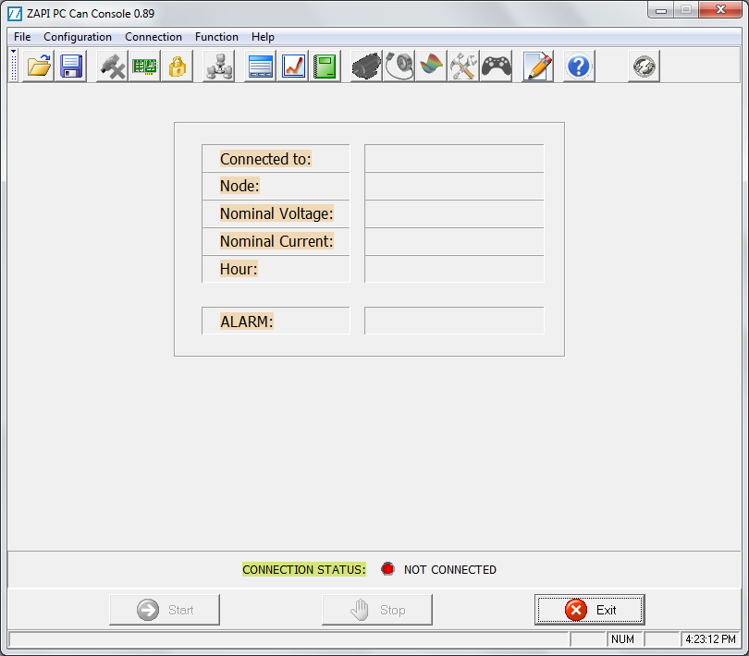

3.CONFIGURATION - CAN DEVICE \\zapi-fs\Applicatori\SWZapi\Guide\imgCANCONSOLE\ConfigurationButton.gif permit to Select the USB-to-CAN device, the Baud Rate and the Communication protocol to connect with the inverter.

CANOPEN PROTOCOL: For all inverter 2uC or single uP set like canopen

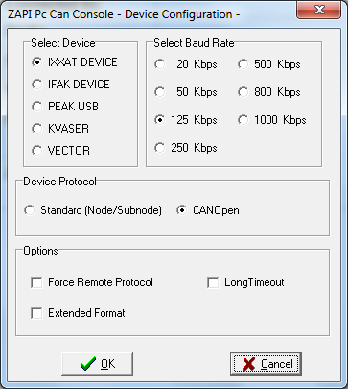

In this example, it is used an IXXAT Device set with a 125 kbps Baud Rate (depending on the controller) and Standard Protocol (Zapi Protocol).

FORCE REMOTE PROTOCOL – (Suggested to use only in case of communication problem) communicate with the controller using the serial protocol. If the Remote protocol is not forced the Speed communication will be faster using the CAN message.

LONG TIMEOUT – (suggested not to use)

Confirming with OK button the device parameter will be opened the configuration window to select USE IXXAT CONFIGURATION checkbox

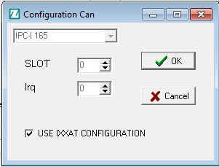

Confirming the CONFIGURATION CAN then select the used IXXAT device connected to the PC for the communication of the Controller (on the example is shown only one device but It could be more) indicated on Device Number:

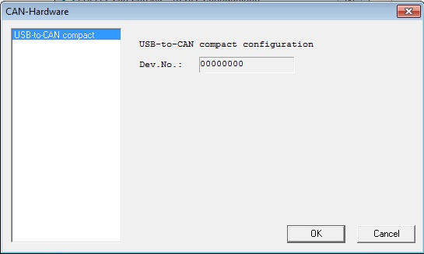

CANOPEN PROTOCOL 🡪 Only one inverter stand-alone on can-bus line (for example inverter set like traction or canopen using to connect by SDO with new generation of inverter with 2uC):

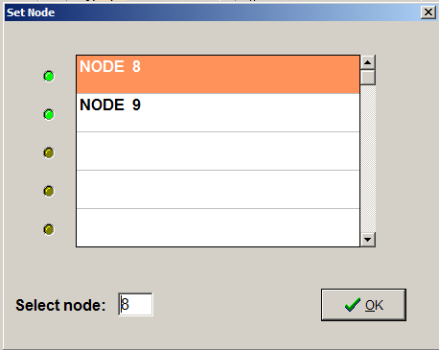

**SET MODEL Node or Node in Standard Protocol:**

|  |  |  |
| --- | --- | --- |
| **Number associated in CANBUS net inverter 1uP** | **Number associated in CANBUS net for inverter 2uC** | **Module Zapi** |
| Not available | Not available | Sicos |
| 8 | 8-9 | Traction |
| 12 | 12-13 | Traction Master |
| 16 | 16-17 | Traction Slave |
| 20 | 20-21 | Pump |
| 24 | Depend from software installed  24-25 | EPS-AC/EPS-AC0/EPSACW |
| Not available | Not available | Can Tiller/VCM |
| Not available | Not available | Mhyrio Flash |
| Not available | Not available | Smart Antenna |
| 64 | Not available | Smart/Eco-smart/Graphic smart **display** |

NOTE: Sometimes it may be necessary to force the node manually to connect to the Zapi control unit to which you want to connect, follow the table above.

4.Selecting the desired node and the sub-node, click OK and START button in the main window:



Try establish the connection between PC and the ZAPI controller. The status LED in the lower part of the will change when connection will be successful:



the right central part of the window 4 green LEDs will light and on the main window will appear the information concerning the software version, the node number, the nominal battery voltage and current, the hour counter, and if present the last detected alarm.

5.If everything is ok, you will connected with inverter that will show you window like below, with the main information of inverter:

**CONNECT TO:** SOFTWARE VERSION INSTALLED ON INVERTER

**NODE:** NODE WHERE YOU ARE CONNECTED

**NOMINAL VOLTAGE:** NOMINAL VOLTAGE OF BATTERY (SETTED BY PARAMETER)

**NOMINAL CURRENT:** NOMINAL CURRENT OF INVERTER (SETTED BY PARAMETER)

**HOUR:** WORKING HOUR COUNTER OF INVERTER

**ALARM:** IT WILL SHOW ALARM, CHECK USER MANUAL OF INVERTER FOR MEANING OF ALARM SHOW.

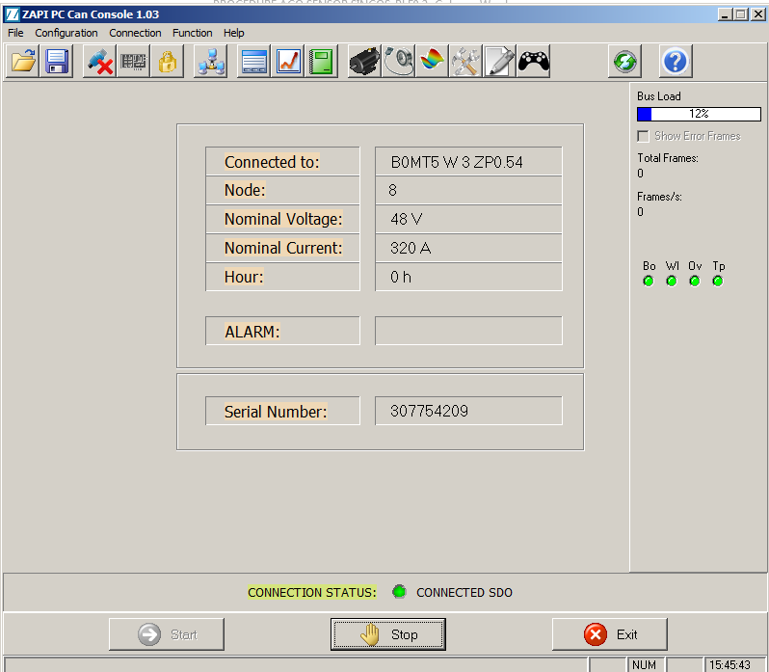

6.CONFIGURATION - ENTER PASSWORD \\zapi-fs\Applicatori\SWZapi\Guide\imgCANCONSOLE\EnterPasswordButton.gif enable to change the controller parameters.

It is necessary to insert the right password, “**ZAPI**” with all capital letters:

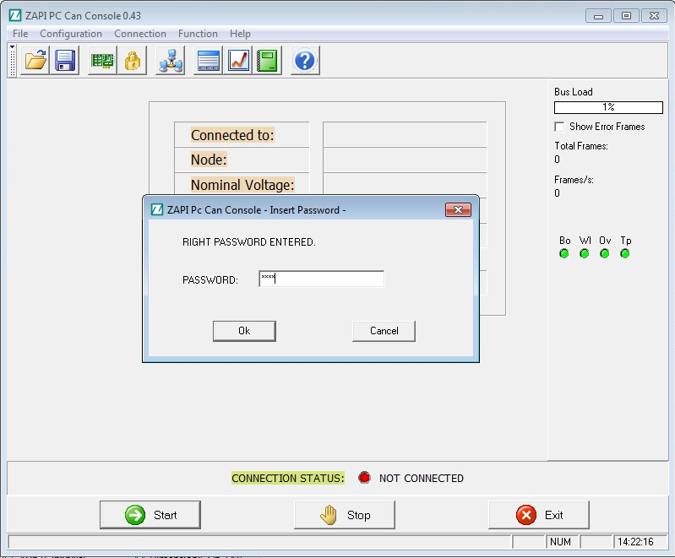

***7.IMPORTANT: Download csv file with final, definitive and correct parameter for the application, it is possible before check by a Verify if the parameter are just correct and aligned with definitive csv file parameter.***

***If not must be download correct csv file parameter by TxFile button, below how to do.***

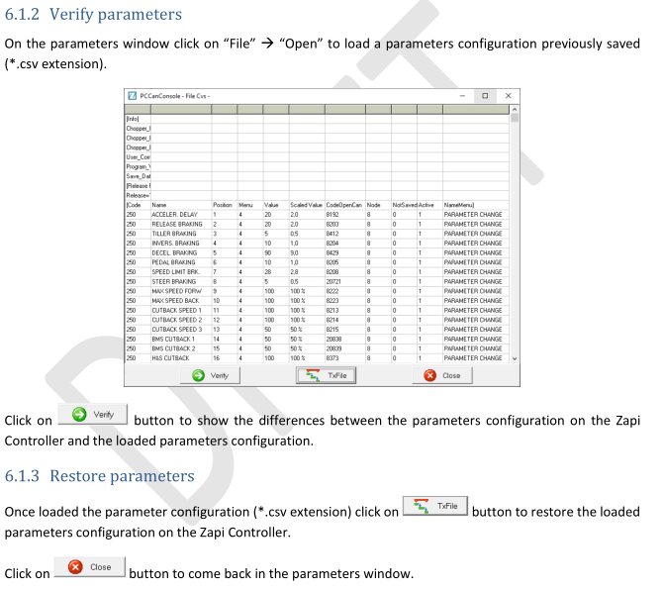

8. If all setting are ok, you could found at first key on of inverter alarm **“OFFSET SPD.SENS.”**, it means that inverter have not acquire sensor sin/cos, **you must acquire sensor but with motor disconnect from gearbox.**

**OFFSET SPD.SENS.** *(MDI/LED code = 3)*

Cause:

It is necessary to acquire the offset angle between the stator and the speed sensor, i.e. they mutual angular misalignment. An automatic function is dedicated to this procedure.

Troubleshooting:

Perform the teaching procedure. See paragraph 7.2.1.

**7.2.1 Acquisition of absolute position sensors**

Absolute position sensors (sin/cos, 3-Hall, resolvers) are crucial in the control of synchronous motors. Amplitude and offset of analog signals and the relative angular offset between the sensor orientation and the motor case must be properly set before starting a synchronous motor for the first time.

9. START with procedure of “ABSOLUTE ACQUIRE SENSOR”, click on picture  ****:

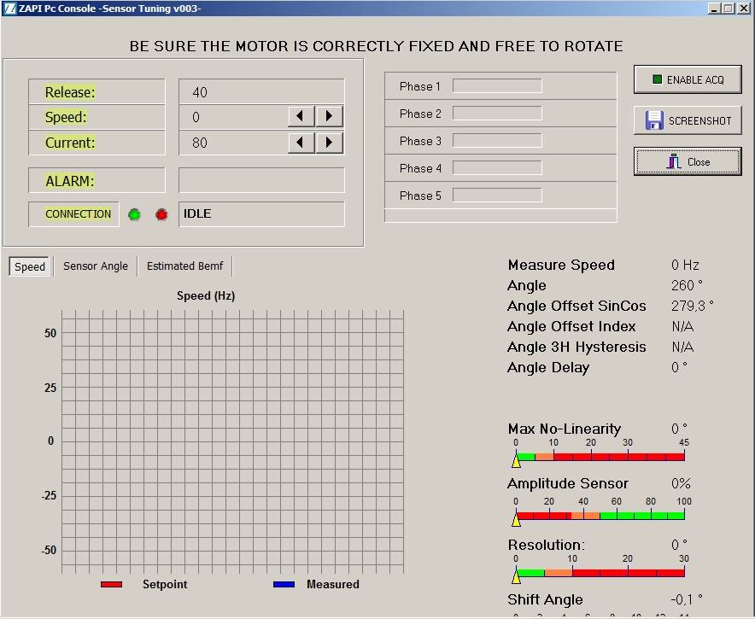

10. Click on “enable acquire”  to enable procedure, then give command of FORWARD, system will start acquiring and motor start to run automatically:

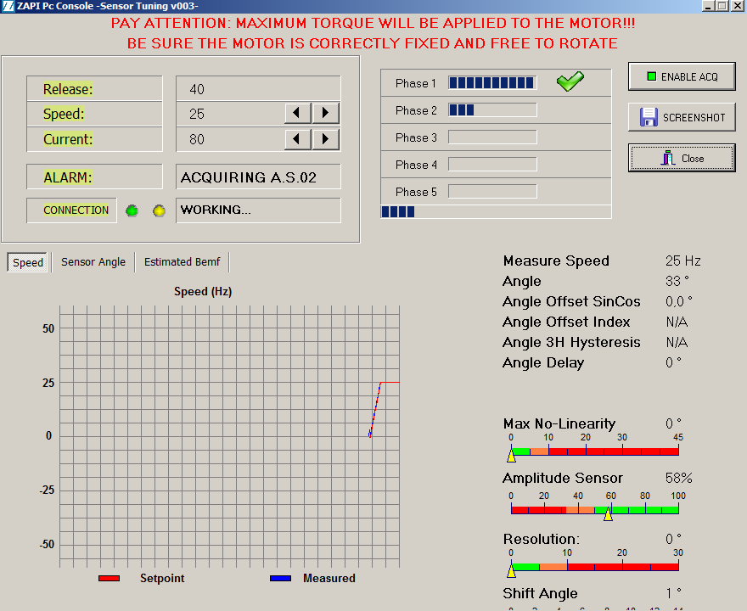

11. Once the sensor tuning process has started, the 5 phases will be performed (PHASE 1 ... 2 ... 3 ... 4 ... 5) that if they are successful they will give the positive result with a GREEN SPUNTA and then TERMINATED.

If the whole process has been successful, it will show you ***ACQUIRE END***.

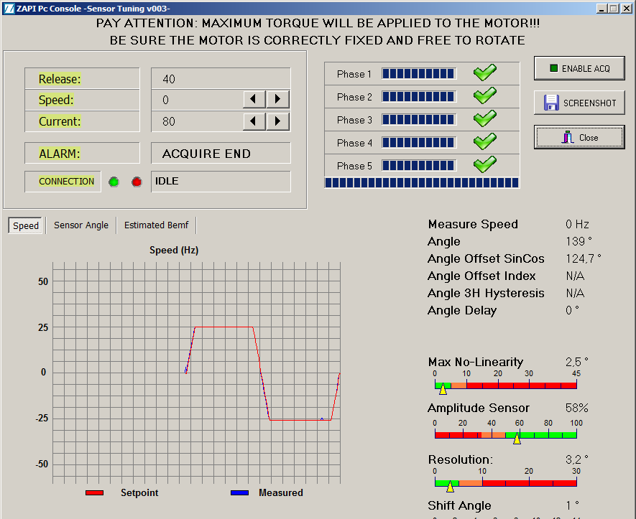

At this point, CLOSE and restart inverter, parameters was just automatically store in memory of inverter.

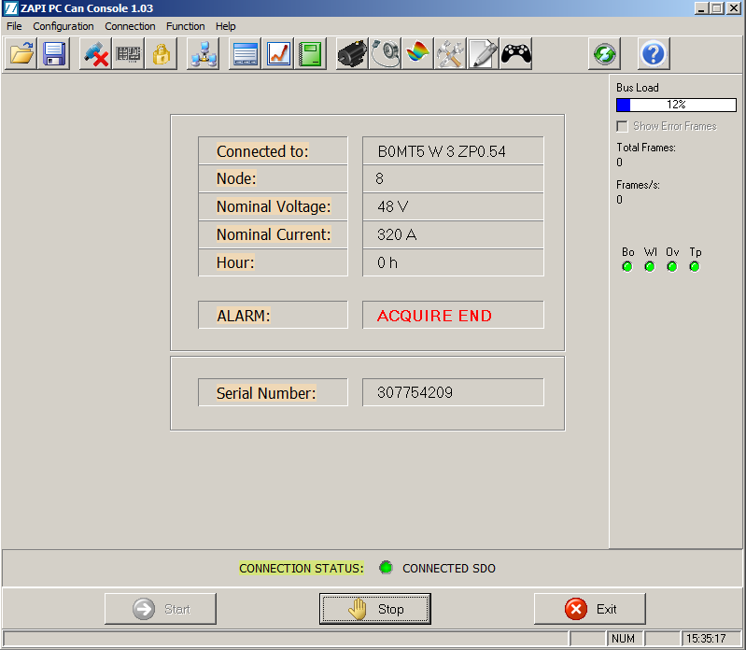

12. If during “acquire sensor”, process stop showing alarm, check on Zapi user manual ALARM LIST with cause and troubleshooting.

***E.g. of possible alarm:***

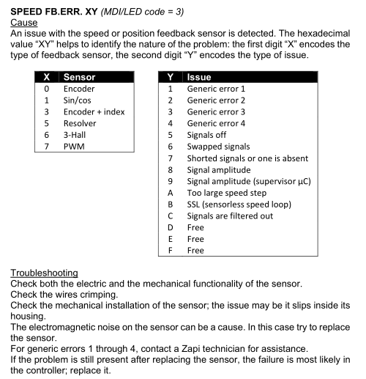

NOTE: If you enter in menu for **ABSOLUTE SENSOR ACQUISITION** procedure and you “screen” in the line connection not “IDLE” but always **“NO SUPPORTED”**, could be possible that you have an old software version that not support ACQUIRING SENSOR or AUTOTUNING PROCEDURE, you must upgrade software version.

13. When you finish “acquire sensor procedure”, after saving of parameter and reset of key, check that motor run with no alarm.

**NOTE: PROCEDURE OF ACQUIRE SENSOR FINISH AT POINT 13.**